

**Line following robot initial build spec**

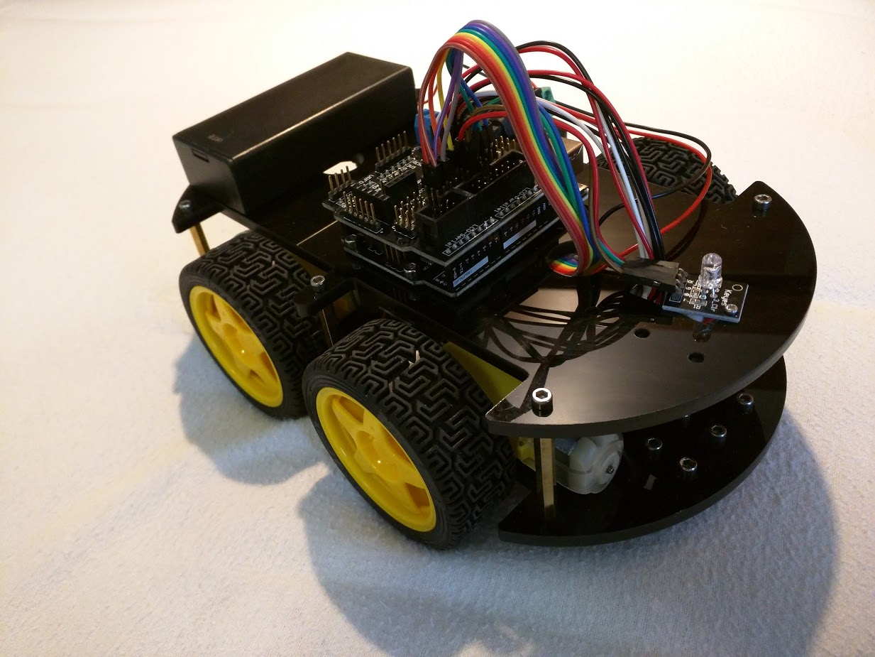

1. **Motor alignment**

As shown in the diagram, the two front motors (at the bottom right of the picture) should have their red (+ve) cables uppermost, and the two rear facing motors (upper left of the picture) should have their black (-ve) cables uppermost.

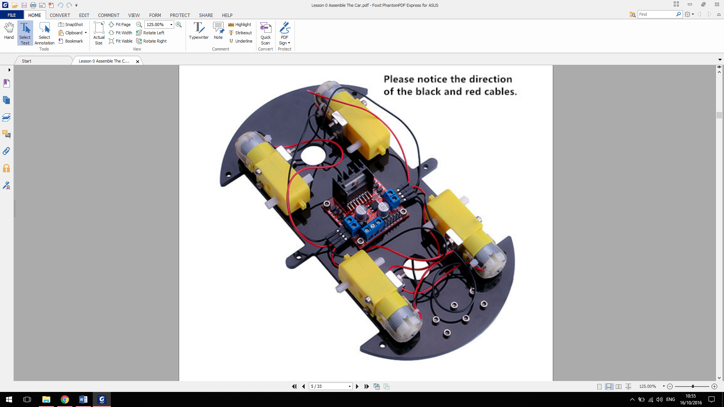

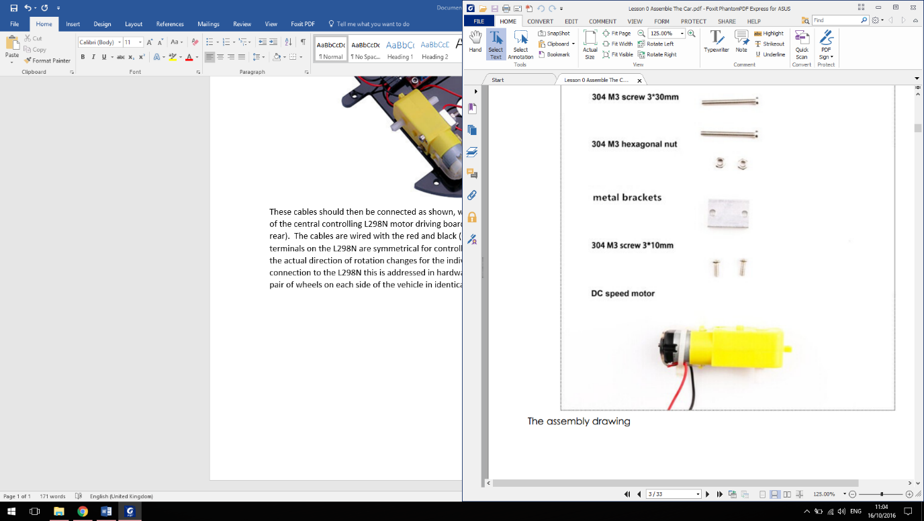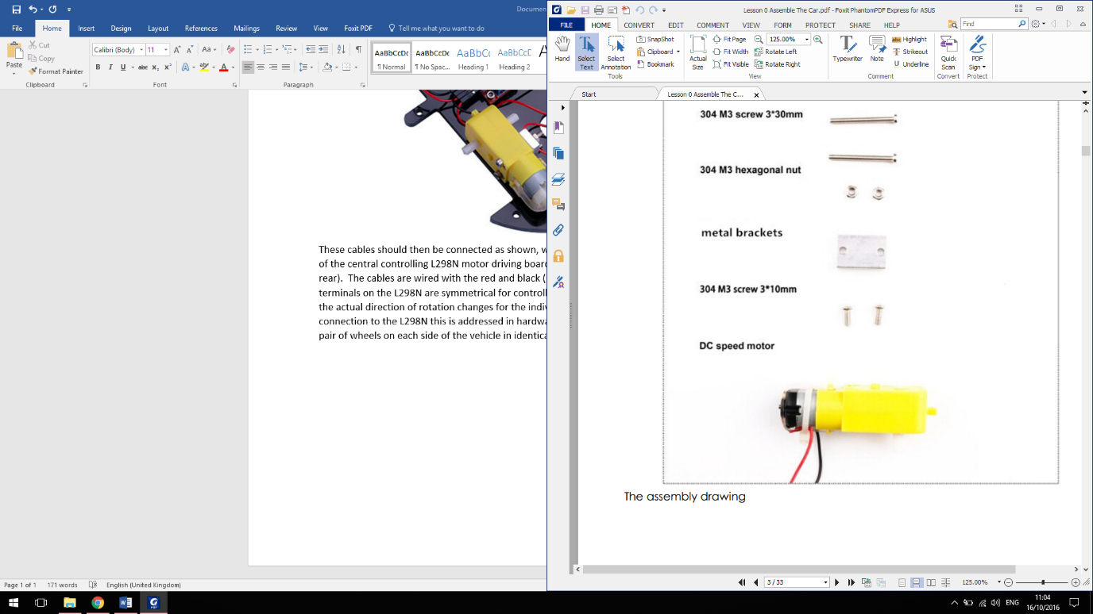These cables are connected as shown, with each side of the vehicle connected to a side of the central controlling L298N motor driving board (installed with the heat sink to the rear). The cables are wired with the red and black (+ve and -ve) into opposite power terminals on each side so that the terminals on the L298N are symmetrical for controlling forwards and backwards motion in code. The actual direction of rotation changes for individual motors, but by switching the red and black connection to the L298N for each side of the vehicle this is addressed in hardware and enables the programming to control the pair of wheels on each side of the vehicle in identical terms for forward and backward motion.

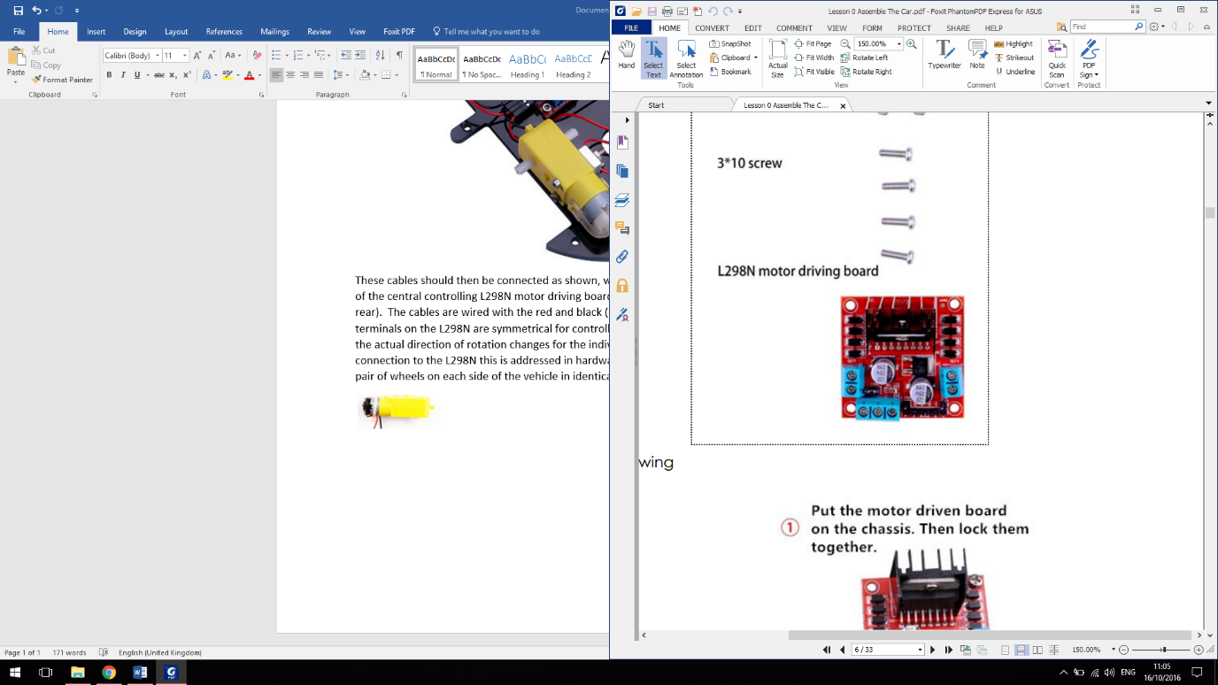Black wire uppermost on motors

Red wire uppermost on motors

Power from battery pack

1. **Arduino Sensor Shield connections**

The robot is controlled by an Arduino controller, which has a further sensor shield installed on top of it to provide additional input/output points. In the initial build of the line following robot the setup is:

|  |  |  |  |
| --- | --- | --- | --- |
| **Shield ID** | **Pin # (in code)** | **Connected to** | **Wire(s) colour** |
| 0 | 0 | - |  |
| 1 | 1 | - |  |
| 2 | 2 | - |  |
| 3 (PWM) | 3 | - |  |
| 4 | 4 | - |  |
| 5 (PWM) | 5 | ENA on motor board – set power to right motors | Red (Brown to V) |
| 6 (PWM) | 6 | ENB on motor board – set power to left motors | Purple (Grey to V) |
| 7 | 7 | N1 on motor board – set right hand side rotation | Orange |
| 8 | 8 | N2 on motor board – set right hand side rotation | Yellow |
| 9 (PWM) | 9 | Red input to LED | Red |
| 10 (PWM) | 10 | Green input to LED | Green |
| 11 (PWM) | 11 | Blue input to LED | Blue |
| 12 | 12 | N3 on motor board – set left hand side rotation | Green |
| 13 | 13 | N4 on motor board – set left hand side rotation | Blue |
| A0 | 14 | Left optical sensor input | White, Red, Black |
| A1 | 15 | Middle optical sensor input | White, Red, Black |
| A2 | 16 | Right optical sensor input | White, Red, Black |
| A3 | 17 | - |  |
| A4 | 18 | - |  |
| A5 | 19 | - |  |

For each numbered point on the shield there are 3 connections (labelled S, V and G) these are; Signal, Volts (5V) and Ground). The input/output pin is the bottom S pin, and the additional power pins are only needed where additional power is required (the ENA/ENB connections to the motors and for the optical sensors).

Pins 0-13 are digital Input-Output and A0-A5 are analogue (thus the ‘A’ prefix). Of the digital pins numbers; 3,5,6,9,10,11 are Pulse Width Modulated (PWM). This means that their input/output is not just a binary ON or OFF but can be set to a specific value from 0-255. These pins have therefore been selected to enable the speed of the motors to be controlled (pins 5 and 6) and to enable more precise control of the colour of the LED (pins 9, 10 and 11).

The direction of rotation for the wheels is set by the difference between the motor board input pins, with **pin 7 (N1)** **LOW and pin 8 (N2) HIGH** the right hand wheels will turn **forwards**. If pin 7 is HIGH and pin 8 is LOW the right hand wheels will turn backwards, in both cases the power / speed is set from the PWM on pin 5 (ENA). Likewise, on the left hand wheels if pin 12 (N3) is LOW and pin 13 (N4) is HIGH the wheels will turn forwards, and vice versa with power controlled from the PWM on pin 6 (ENB).

Note that although the analogue pins (A0, A1 and A2) are used for the optical sensors we are using the sensors only to provide a binary contrast (line is sensed or not), therefore these pins are being used as if they were digital. In code they are read with a digitalRead command returning either “HIGH” or “LOW”.

1. **Connection diagram**

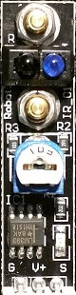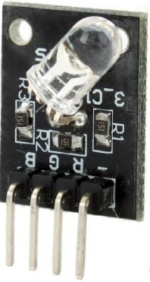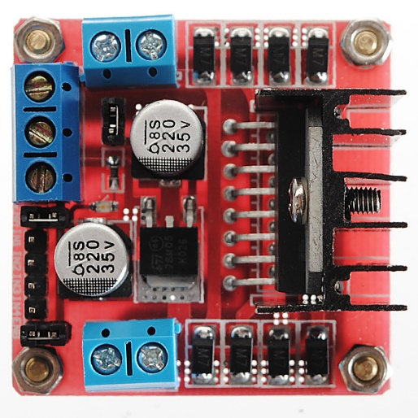(Note; light green used for white wires )

Right Sensor

Centre Sensor

Left Sensor

Vehicle Motor

Vehicle Motor

Vehicle Motor

Battery Pack

(Also connected to Arduino beneath shield)

Vehicle Motor

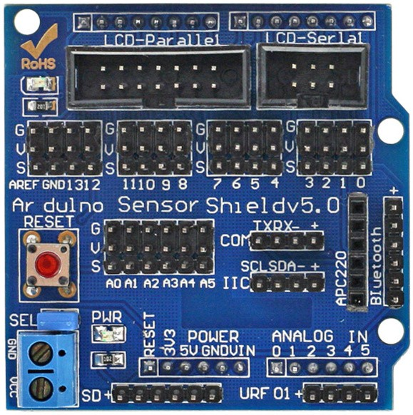

1. 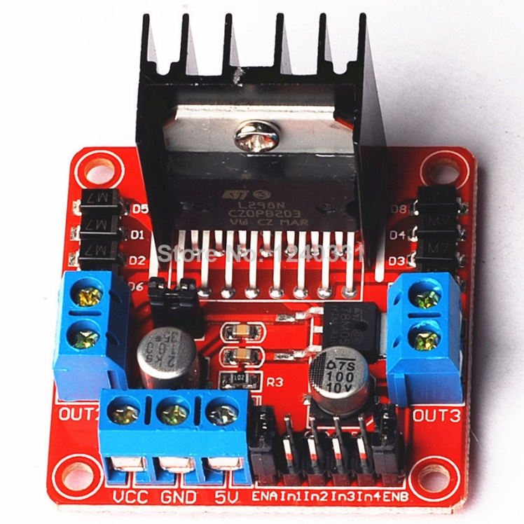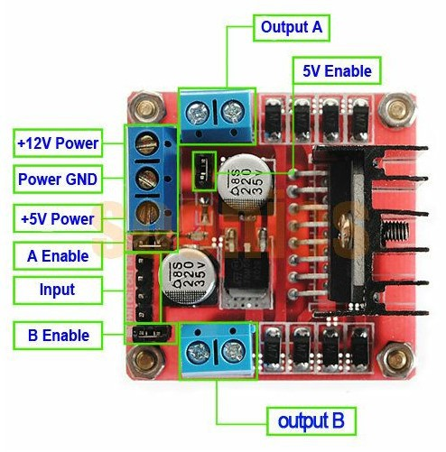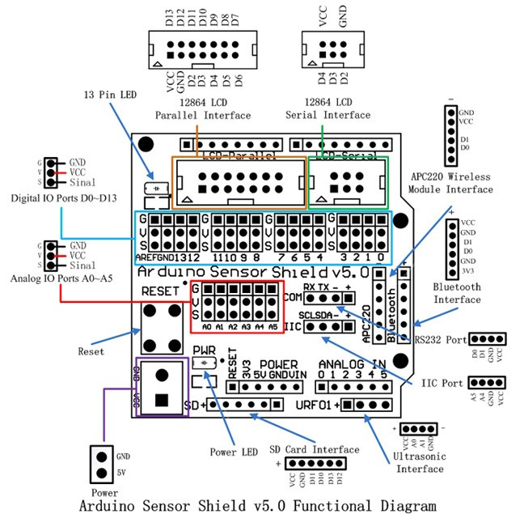A**dditional information on Arduino Sensor Shield v5.0 and L298N motor control board**